|  |  |  |  |  |  |  |
| --- | --- | --- | --- | --- | --- | --- |
| VILNIAUS KOLEGIJA  UNIVERSITY OF APPLIED SCIENCES  FACULTY OF ELECTRONICS AND INFORMATICS  Image result for viko logo | | |  | | | VILNIUS COLLEGE  Image result for viko logoFACULTY OF ELECTRONICS AND INFORMATICS |
|  | | |  | | |  |
| **ECONOMICS** | | |  | | | **INTRODUCTION TO INFORMATICS** |
| PRACTICAL ASSIGNMENT  6531BX028 PI18E | | |  | | | PRACTICAL ASSIGNMENT  SPOTIFY USER MANUAL  6531BX028 PI18E |
| STUDENT | EVALDAS PAULAUSKAS,  DZIUGAS PECIULEVICIUS  LUKAŠ JUTKEVIČ | STUDENT | | DŽIUGAS PEČIULEVIČIUS |
| (SIGNATURE)  6/5/2020 | | |  | | | LECTURER |
| LECTURER | AGNĖ ŠIMELYTĖ | (SIGNATURE)  10/17/2018 | | VIRGILIJUS KUKLIERIUS |
| (SIGNATURE)  6/5/2020 | | |  | | | 2018 |

2020

# TABLE OF CONTENTS

TABLE OF CONTENTS 2

INTRODUCTION 3

Analysis of business sector 4

**Volume of the sector** 4

**Analysis of industry competitors** 5

Analysis of the environment of the company 8

**Main activities of the company** 8

**Market size estimation** 8

**Targeted customer segment** 9

**Products range, pricing, and differentiation** 10

**Analysis of company’s suppliers** 11

**Organizational structure of the company** 12

**Future development opportunities** 14

vertical analysis 16

Horizontal analysis 17

Twelve main ratios 18

**Z-Altman's coefficient for the bankrupt prediction** 19

References 20

# TABLE OF FIGURES

Table 1 - Airbus (commercial) customers chart 9

Table 2 - Airbus commercial pricing 11

Table 3 - Airbus products, customers, competitors 12

Picture 1 - Airbus corporate structure 14

Picture 2 - Vertical analysis 16

Picture 3 - Horizontal analysis 17

Picture 4 - Twelve main ratios 18

Picture 5 – Z-Altman's calculations for the bankrupt prediction 19

# INTRODUCTION

This project report analyses Airbus business sector, its changes and its influencing factors, volume of the sector and main competitors. Calculate 12 main ratios for Airbus and use Z-Altman's formula to help determine the financial health of a company.

**Purpose**

Purpose of this project is to analyze the company, its environment and calculate

# Analysis of business sector

Airbus is a tertiary business sector. It’s also called a service sector and involves the selling

of goods and products. Airbus is a European aircraft-manufacturing consortium formed in 1970 to fill a market niche for short- to medium-range, high-capacity jetliners. It is now one of the world’s top two commercial aircraft manufacturers, competing directly with the American Boeing Company and frequently dominating the jetliner market in orders, deliveries, or annual revenue. The Company is also a European leader providing tanker, combat, transport and mission aircraft, as well as one of the world’s leading space companies

2018 was the year Airbus operated as One Company after the completion of the Airbus Group and Airbus integration. This evolution simplified our company’s governance, eliminated redundancies and supported further efficiencies, while at the same time driving further integration of the entire group. The Company overall will derive considerable benefit from the integration through more focused business support and reduced costs.

With consolidated revenues of €63.7 billion in 2018, the Company is a global leader in aeronautics, space and related services. Airbus offers the most comprehensive range of passenger airliners. As for helicopters, the Company provides the most efficient civil and military rotorcraft solutions worldwide. In 2018, it generated 84.5% of its total revenues in the civil sector (compared to 85% in 2017) and 15.5% in the defense sector (compared to 15% in 2017). As of 31 December 2018, the Company’s active headcount was 133,671 employees.

In recent years Airbus Defense and Space continued to reshape its portfolio and refocus on military aircraft, missiles, launchers and satellites. The Company pursued the divestment process of the businesses that do not fit with the new strategic goals and have better futures in more tailored ownership structures. The Company completed the divestment of its North American Airbus DS Communications Inc. Business.

## **Volume of the sector**

Airbus is an international pioneer in the aerospace and defense industry. They lead in designing, manufacturing and delivering aerospace products, services and solutions to customers on a global scale. A&D sector can be generally described as Oligopoly, because few firms dominate this sector of the market, such as Airbus, Boeing and Lockheed Martin.

The global aerospace industry was worth $838 billion in 2018:

* Aircraft and Engine parts manufacturing represented 28% of the sector value (about $235 Bn)
* Civil & Military aircraft maintenance and upgrades represented 27% (about $226 Bn)
* Aircraft Systems and Component Manufacturing represented 26% (about $218 Bn)
* Satellites and Space represented 7% (about $59 Bn),
* Missile & Military Drone production and maintenance represented 5% (about $42 Bn)
* Other activity, such as flight simulators, defense electronics, public research accounted for 7% of the market volume (about $59 Bn).

In 2018 countries with the largest market share in aerospace and defense sector were led by the US with $408.4 Bn (49%) followed by France with $69 Bn (8.2%) then China with $61.2 Bn (7.3%), United Kingdom with $48.8 Bn (5.8%) and other countries such as Germany, Russia, Canada etc. that accounted for 29.7% in the marked share.

The revenues of the top 20 global A&D companies accounted for nearly 73.6 percent or US$504.6 billion of the overall A&D industry revenues in 2018, in line with the 73.8 percent in 2017, which indicates that the industry continues to be concentrated.

## **Analysis of industry competitors**

Airbus Group is a multinational aerospace and defense company this means that it doesn't really have any local business competition. Therefore, main Global level competitors in A&D sector are:

* Boeing - American corporation that designs, manufactures, and sells airplanes, rotorcraft, rockets, satellites and other A&D products. Boeing also provides leasing and product support services. It’s the largest global aerospace manufacturer and second largest defense contractor based on 2018 revenue of $101.0 Bn. In 2019 it fell to $76.6 Bn likely due to Covid-19 impact on global economy.
* Lockheed Martin - American A&D corporation with worldwide interests that mainly focuses on defense contracts. It employs approximately 110,000 people worldwide as of January 2020. Lockheed Martin main customer is U.S. Department of Defense, it provides company with half of its sales. 2018 revenue $53.8 Bn that increased in 2019 to $59.8.
* Northrop Grumman Corporation - is an American global A&D technology company. With 90,000 employees[[4]](https://en.wikipedia.org/wiki/Northrop_Grumman#cite_note-About_Us-4) and an annual revenue in excess of $30 billion in 2018, it is one of the world's largest weapons manufacturers and military technology providers. Its revenue in 2019 vas $36.6 bn.
* GE Aviation - a subsidiary of General Electric is among the top aircraft engine suppliers and offers engines for most commercial aircraft. GE Aviation is part of the General Electric conglomerate, which is one of the world's largest corporations. With revenue of $30.6 bn in 2018.

In Civil Aerospace engineering sector Airbus has been operating in a duopoly since Lockheed’s withdrawal from the market in 1986 and Boeing’s acquisition of McDonnell Douglas in 1997. As a result, the market for passenger aircraft of more than 100 seats has been divided between Airbus and Boeing. According to the manufacturers’ published figures for 2018, Airbus and Boeing, each accounted for 50% of total commercial aircraft deliveries, 46% and 54% of total net orders (in units), and 56% and 44% of the total year- end backlog (in units). With 800 deliveries, 2018 was Airbus’ 16th year in a row of increased production

Airbus Helicopters’ primary competitors in the civil and parapublic sector are Leonardo and Bell Helicopter. Sikorsky and Russian Helicopters (except in Russia) continue to reflect very low order intake in the C&P market while concentrating their activity on the military sector. The civil and parapublic sector has seen more local competitors in recent years (China, India, Japan, South Korea, Turkey). Airbus Helicopters has maintained its leading market share (in bookings of 2.0t helicopters and five seats and above), in a low market, Customers with ~52% in unit in 2018, followed by Leonardo and Bell with respectively 26% and 13%. Airbus Helicopters’ main competitors in the military sector are Sikorsky, Boeing and Russian Helicopters, thanks to large captive market and strong political support for export. The military sector is highly competitive and is characterized by major restrictions on foreign manufacturers’ access to the domestic defense bidding process (i.e. USA, China, Russia). Thanks to several major contracts (i.e. H145M/Lakota and NH90), Airbus Helicopters increased its market share on this sector (in units) from 9% in 2017 to 25% in 2018. The Company will continue to focus on large military campaigns in 2019.

The market for military aircraft is dominated by large and medium-sized American and European companies. The main competitors in military transport and mission aircraft include Boeing, Embraer, Lockheed Martin, Leonardo, UAC, Kawasaki, AVIC and Antonov**.** Heavy military transport has historically been driven by US policy and budget decisions and has therefore been dominated by US manufacturers and split in strategic and tactical aircraft segments. The A400M represents the Company’s entry into this market, at a time when nations are expected to begin replacing their existing fleets. The aircraft is designed to disrupt the divide between strategic and tactical transport by offering both capabilities in one. This saves both time and cost as you can fly a long-range strategic aircraft into a tactical zone of operation. In terms of revenues, Airbus Defense and Space is the largest continental European combat aircraft manufacturer. The major combat aircraft activities are taking place through the contribution to the Eurofighter Typhoon programme jointly with the consortium partner companies BAE Systems and Leonardo. Competitors in the segment of combat aircraft include Boeing, Dassault, Lockheed Martin, Saab and UAC.

# Analysis of the environment of the company

## **Main activities of the company**

Airbus is a multinational aerospace corporation. Airbus is the world's largest airliner manufacturer that creates most civil airliners. It designs, manufactures and sells civil and military aerospace products worldwide and manufactures aircraft in the European Union and various other countries. The company has three divisions: Commercial Aircraft (Airbus S.A.S.), Defense and Space, and Helicopters, the third being the largest in its industry in terms of revenues and turbine helicopter deliveries. The company's main civil airplane business is conducted through the French company Airbus S.A.S. based in Blagnac, a suburb of Toulouse, with production and manufacturing facilities mostly in Europe (France, Germany, Spain, United Kingdom) China, US and Canada. Final assembly production is based in France, Germany, China and United States.

## **Market size estimation**

The long-term market for passenger aircraft depends primarily on passenger demand for air travel, which is itself primarily driven by economic or GDP growth, fare levels and demographic growth. Airbus’ new Global Services Forecast predicts a US$4.6 trillion worldwide market for commercial aircraft services from 2018 to 2037. The new analysis is based on a three-way market segmentation, respectively focusing on the aircraft, the airline operation, and the passenger experience. Preliminary figures released at the end of 2018, by the International Civil Aviation Organization (ICAO), confirmed that some 4.3 billion passengers made use of the global air transport network for their business, tourism needs or for simply visiting friends and relatives in 2018. The annual passenger total is up 6.1% compared to 2017 and the number of departures rose to approximately 38 million globally. World passenger traffic, expressed in terms of total scheduled revenue passenger-kilometers (RPKs), posted an increase of 6.7% with approximately 8.2 trillion revenue passenger kilometers performed.

In 2019 Airbus released rather optimistic long-term growth potential estimation, company predicts that market size will double in next 15 years. Since demand in Air travel will increase and that will lead to growth in aero plane demand. In 15 years, company expects to increase replace more than 10 thousand of its existing airplanes and sell more than 20 thousand.

But this growth estimation may be rather wrong if one would consider impact of Covid-19 pandemic on global economy and airplane travel in 2020. Its predicted that total recovery from pandemic effects on air travel may take up to 4 years.

According to market forecasts produced by Airbus Helicopters, around 22,000 civil helicopters and 14,000 military helicopters are expected to be built globally over the next 20 years. This forecast, particularly with respect to the military sector, relies to a large extent on large US development programmes. Overall, the global helicopter market is still evolving in a difficult environment, despite improved economic indicators in 2018.

Airbus Defense and Space is mainly active in public and para-public markets. As a general trend, defense budgets in Europe are expected to continue to grow, triggered by geopolitical tensions, heightened security risks and reinforced by recent discussions on NATO defense spending target of 2% of GDP. Airbus Defense and Space, in conjunction with Airbus, is well-placed to benefit from growth in defense expenditure. The upward outlook for defense spending may continue to drive M&A activity in the industry as has been the case since 2017. The market may be influenced in the short-term by a potential softening of the global economy and Covid-19 caused effects.

## **Targeted customer segment**

As of 31 December 2018, Airbus had 414 customers and a total of 19,340 Airbus aircraft had been ordered, of which 11,763 aircraft had been delivered to operators worldwide. The table below shows Airbus’ largest commitments in terms of total gross firm orders by customer for the year 2018.

Table 1 - Airbus (commercial) customers chart

|  |  |
| --- | --- |
| **Customer** | **Firm orders** |
| Avolon | 100 |
| Jetblue Airways | 60 |
| Moxy | 60 |
| Vietjet Air | 50 |
| Scandinavian Airlines | 36 |
| Lufthansa | 32 |
| Aegean Airlines | 30 |
| Delta Air Lines | 25 |
| Turkish Airlines | 25 |
| Viva Aerobus | 25 |

More than 3,000 operators currently fly Airbus Helicopters’ rotorcraft in over 150 countries. Airbus Helicopters’ principal military clients are Ministries of Defense (“MoDs”) in Europe, Asia, the US and Latin America. In the civil and parapublic sector, Airbus Helicopters has a leading market share in Europe, the Americas and Asia-Pacific.

With 54% of the worldwide market share-based on deliveries in 2018, the versatility and reliability of Airbus Helicopters products have made them the preferred choice of the most prominent civil and parapublic customers (turbine helicopters of five seats and above).

The Military Aircraft Programme Line with its products combat aircraft, military transport aircraft, mission aircraft and related services supplies the public sector, mainly armed forces.

Customer relationships in this segment are characterized by their long-term, strategic nature and long decision-making cycles. Once a contract is signed, its life span including considerable services business often amounts to decades. Beyond a strong foothold in home countries, the customer base is increasingly global, due to the success of the A330 MRTT and C295 programmes.

The turbulence created by changes in the US administration and the Russian situation is gradually leading to a shift in importance of defense in Europe. The commitment to go towards 2% of the GDP is being gradually pursued and should lead to new optimism for the sector. The Franco-German declaration in summer 2017 and the establishment of “Permanent Structured Cooperation (PESCO)” by the European Union on 11 December 2017 are also clear signals in this direction.

## **Products range, pricing, and differentiation**

Airbus’ diverse product line includes everything from passenger jetliners to freighters and private jets. Ranging in size from 100-seat jetliners to the double-deck A380 that can transport more than 850 passengers, the total versatility of Airbus’ product line allows it to offer a variety of tailored solutions to meet the needs of any airline and their market – from low-cost and full-service carriers to the air freight and VIP transport segments.

Airbus Helicopters offers a complete range of helicopters that covers nearly the entire civil and military market spectrum, which it continuously improves with leading-edge technologies. This product range includes single-engine, light twin-engine, medium and medium-heavy helicopters, and is based on a series of new-generation platforms designed to be adaptable to both military and civil applications. In addition, products share multiple technical features as part of a family concept approach.

Airbus Defense is the largest defense supplier in Europe, and among the top 10 defense companies worldwide. It manufactures tactical and strategic airlifters, multi-role aerial tankers and advanced combat aircraft. Together, the A400M, C295, CN235, A330 MRTT and Eurofighter Typhoon make up a world-class product line operated by air forces worldwide. Airbus also is the no. 3 company worldwide in secure communication platforms, delivering agile, innovative, data-driven digital services for defense and cyber security applications.

Table 2 - Airbus commercial pricing

|  |  |
| --- | --- |
| **Airbus aircraft 2018 average list prices (USD millions)** | |
| A220-100 | 81 |
| A220-300 | 91.5 |
| A318 | 77.4 |
| A319 | 92.3 |
| A320 | 101.0 |
| A321 | 118.3 |
| A319neo | 101.5 |
| A320neo | 110.6 |
| A321neo | 129.5 |
| A330-200 | 238.5 |
| A330-800 (neo) | 259.9 |
| A330-200 Freighter | 241.7 |
| A330-300 | 264.2 |
| A330-900 (neo) | 296.4 |
| A350-800 | 280.6 |
| A350-900 | 317.4 |
| A350-1000 | 366.5 |
| A380 | 445.6 |

## **Analysis of company’s suppliers**

Around 80% of Airbus’ activity is sourced. The company works with more than 12,000 suppliers worldwide that provide products and services for flying and non-flying parts. Airbus continuously develops its supplier base, with an overall sourcing volume across the company valued at approximately €49.6 billion. Airbus has identified global sourcing as one of its long-term objectives and aims to source 40% outside Western Europe and the U.S. by 2020. Airbus’ external procurement is equivalent to over two-thirds of the company’s revenues.

Some of the most notable ones, as they recently have won awards for “Industrial performance” awarded by Airbus itself during Airbus Global Supplier Awards Ceremony.

Liebherr Aerospace is the aerospace equipment manufacturing division of the Liebherr Group. The company is an original equipment manufacturer (OEM). Today, Liebherr is not only among the world’s largest manufacturers of construction machinery, but is an acknowledged supplier of technically advanced, user-oriented products and services in many other fields of activity as well. The Group’s holding company, Liebherr International AG, which is based in Bulle, Switzerland, is wholly owned by members of the Liebherr family.

Aleris Corporation is a Delaware corporation with its principal executive offices located in Cleveland, Ohio. Aleris is a holding company and currently conducts its business and operations through direct wholly owned subsidiary, Aleris International, Inc. and its consolidated subsidiaries. Aleris is a global leader in the manufacture and sale of aluminum rolled products, with 13 production facilities located throughout North America, Europe and China. Aleris product portfolio ranges from the most technically demanding heat-treated plate and sheet used in mission-critical applications to sheet produced through our low-cost continuous cast process.

Table 3 - Airbus products, customers, competitors

|  |  |  |
| --- | --- | --- |
| Principal end use/product category | Major customers | Competitors |
| * Aerospace plate and sheet | * Airbus, Boeing, Bombardier, Dassault, Embraer | * Arconic, AMAG, Constellium, Kaiser |
| * Autobody sheet (inner, outer and structural parts) | * Audi, Daimler, Renault, Volvo, VW Group | * AMAG, Constellium, Hydro, Novelis, Profilglass, Maaden, Nanshan |
| * Clad brazing sheet (heat exchanger materials for automotive and general industrial) | * Mahle, Dana, Denso, Hanon, Modine, Chart | * Arconic, AMAG, Cränges, Hydro, UACJ |
| * Industrial plate and sheet (tooling, molding, road & rail, shipbuilding, LNG, silos, anodizing qualities for architecture, multi-layer tubing, and general industry) | * Amari Group, Amco, Euromax, Gilette, Henco, Linde, Multivae, RemiClaeys, SAG, Thyssenkrupp | * Arconic, AMAG, Constellium, Hydro, Novelis, Elval, Aludium, Zhongwang, Nanshan |

## **Organizational structure of the company**

Airbus' Corporate Governance ensures that Airbus is managed according to our Regulating Laws and Articles of Association. Airbus' top-level governing body is the Board of Directors. Responsible for the management of Airbus it delegates the day-to-day management to the CEO who fulfills this task with the support of the Executive Committee. Airbus Governance strives to be a transparent body, matching the expectations of the Company’s shareholders throughout the world.

In 2018, the Company organized its businesses into the following three operating segments:

1. Airbus (formerly Commercial Aircraft)
2. Helicopters
3. Defense and Space.

The merger began mid-2017 and provided the opportunity to introduce a single Airbus brand for the Company and all its entities, effective since January 2017. In 2017, Airbus Group SE’s name was changed to Airbus SE, following approval at the Annual General Meeting. Therefore, Airbus SE together with its subsidiaries is referred to as “the Company” and no longer the “Group”. Consequently, the segment formerly known as “Airbus Commercial Aircraft” is referred to as “Airbus”. In this new set-up, the Company retains Airbus Defense and Space and Airbus Helicopters as Divisions.

At the Executive Committee meetings, the following matters, among others, are discussed:

* Appointment by the Heads of Airbus Divisions and functions of their management teams.
* Major investments.
* Settling and control of the implementation of the strategy for Airbus’ businesses.
* Airbus policy matters and management and organizational structure of the business.
* Performance level of the Company’s businesses and support functions.
* All business issues, including the operational plan of Airbus and its Divisions and Business Units.

The CEO endeavors to reach consensus among the members of the Executive Committee. In the event a consensus is not reached, the Chief Executive Officer is entitled to decide the matter.

The CEO proposes all the Members of the Executive Committee for approval by the Board of Directors, after consultation with the Nomination and Governance Committee and the Chairman of the Board of Directors.

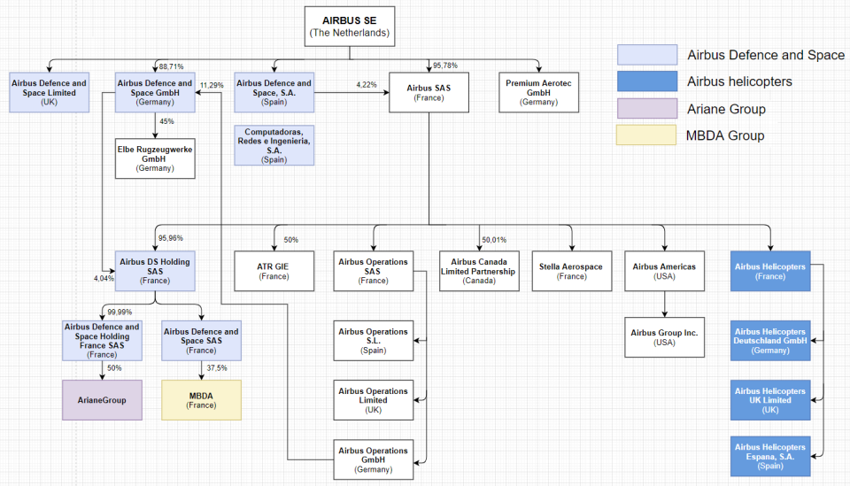

Picture 1 - Airbus corporate structure

## **Future development opportunities**

Airbus is currently on the path to a zero-emission flight. In 2010, Airbus embarked on its electrification journey, developing the world’s first all-electric, four-engine aerobatic aircraft, CriCri. Since then, Airbus has made significant progress in the electrification of flight. In 2015 their all-electric, twin-propeller aircraft E-Fan successfully crossed the English Channel. E-Fan X, the successor to E-Fan that is 30-times more powerful than its predecessor, has provided invaluable insights on serial hybrid-electric propulsion.

This provides a great opportunity for Airbus to become a leader in future of aerospace industry by pioneering electrical or hybrid flight systems while concerns for air pollution and global warming rise higher and higher.

Also, the idea of urban flight in the ever-growing cities of the world could provide a big opportunity for growth if the technology becomes more reliable.

Also as was mentioned previously in the report, NATO defense spending has increased in the recent years, providing Airbus Defense with great opportunities for growth. Because Airbus spends a lot of their resources on research and development, majority of their products and services are bleeding edge technology for example, unmanned aircraft systems (drones), that are sought after by militaries of the world.

# vertical analysis

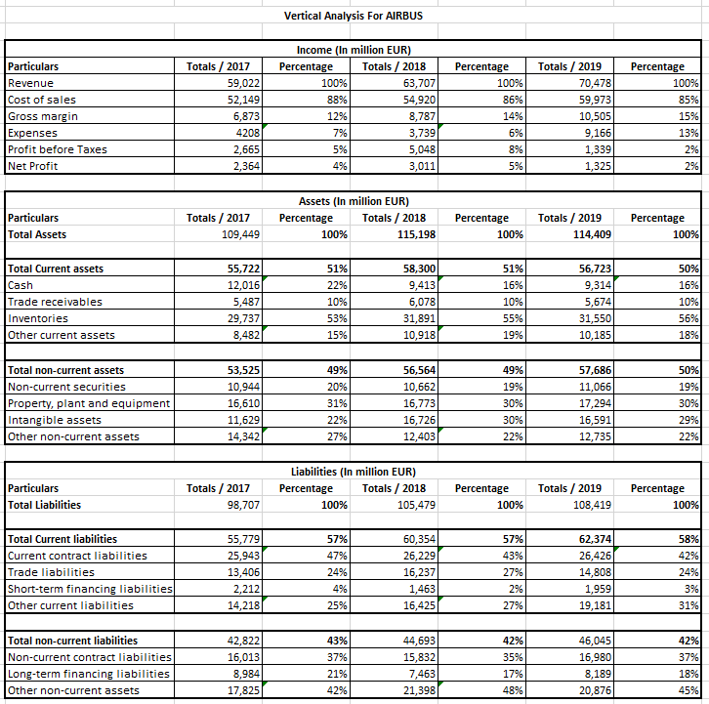

Picture 2 - Vertical analysis

# Horizontal analysis

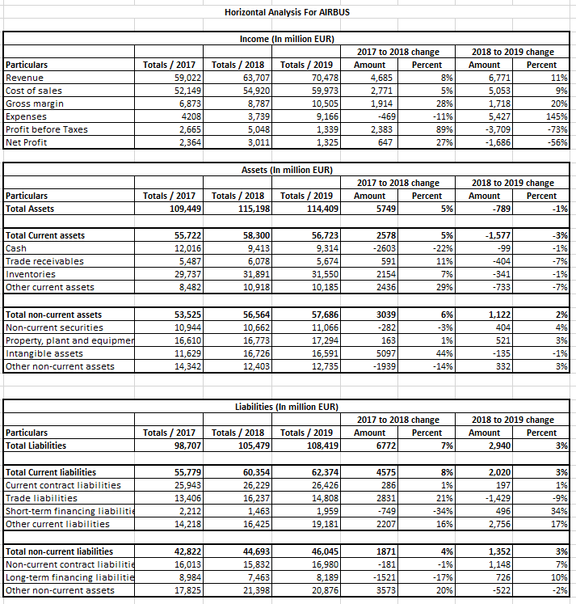

Picture 3 - Horizontal analysis

# Twelve main ratios

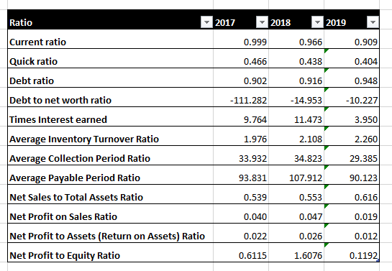

Picture 4 - Twelve main ratios

## **Z-Altman's coefficient for the bankrupt prediction**

The Altman Z Score is used to predict the likelihood that a business will go bankrupt within the next two years. The formula is based on information found in the income statement and balance sheet of an organization. Given the ease with which the required information can be found, the Z Score is a useful metric for an outsider who has access to a company's financial statements.

Formula consists of 5 ratios each multiplied by weight to determine Z score:

* A - Working Capital (Current Assets – Current Liabilities) / Total Assets (Measures liquidity of firm)
* B - Retained Earnings / Total Assets (measures accumulated profits compared to assets)
* C - Earnings Before Interest & Taxes (EBIT) / Total Assets (measures how much profit firms assets are producing)
* D - Market Value of Equity (Mkt. Cap. + Preferred Stock) / Total Liabilities (compares the company’s value versus its liabilities)
* E - Sales / Total Assets (efficiency ratio – measures how much the company’s assets are producing in sales).

Z-Score Results:

* Z-Score of < 1.81 represents a company in distress.
* Z-Score between 1.81 and 2.99 represents the “caution” zone.
* Z-Score of over 3.0 represents a company with a safe balance sheet.

Following formula is used to calculate the coefficient:

Z = 1.2A x 1.4B x 3.3C x 0.6D x 0.99E

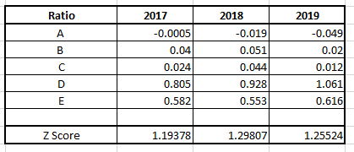

Picture 5 – Z-Altman's calculations for the bankrupt prediction

# References

1. <https://www.airbus.com/defence/uav.html>
2. <https://www.airbus.com/innovation/zero-emission/urban-air-mobility/cityairbus.html>
3. <https://www.airbus.com/investors/financial-results-and-annual-reports.html>
4. <https://www.bbc.com/news/business-54242176>
5. <https://www.airbus.com/newsroom/press-releases/en/2019/05/airbus-honours-best-in-class-defence-and-space-suppliers.html>
6. <https://sec.report/Document/0001518587-19-000008/>
7. <https://www.liebherr.com/en/usa/annual-report/development-and-outlook/development-and-outlook.html>
8. <https://www.liebherr.com/en/ind/about-liebherr/liebherr-worldwide/france/toulouse/toulouse-aerospace.html>
9. <https://www.britannica.com/topic/Airbus-Industrie>\
10. <https://www.airbus.com/content/dam/corporate-topics/facts-and-figures/annual-report/Information-document-2018-pages-24-to-48.pdf>
11. <https://craft.co/airbus-group/competitors>
12. <https://www.owler.com/company/airbus>
13. <https://trace.tennessee.edu/cgi/viewcontent.cgi?referer=https://www.google.com/&httpsredir=1&article=1284&context=utk_gradthes>
14. <https://www.ft.com/content/c9a9a77c-db07-11e3-8273-00144feabdc0>
15. <https://www2.deloitte.com/content/dam/Deloitte/global/Images/infographics/gx-eri-global-a-d-industry-financial-performance-study-2018.pdf>